A Characteristic is a type of info objects that provides context for the business entities that are the subject of analysis.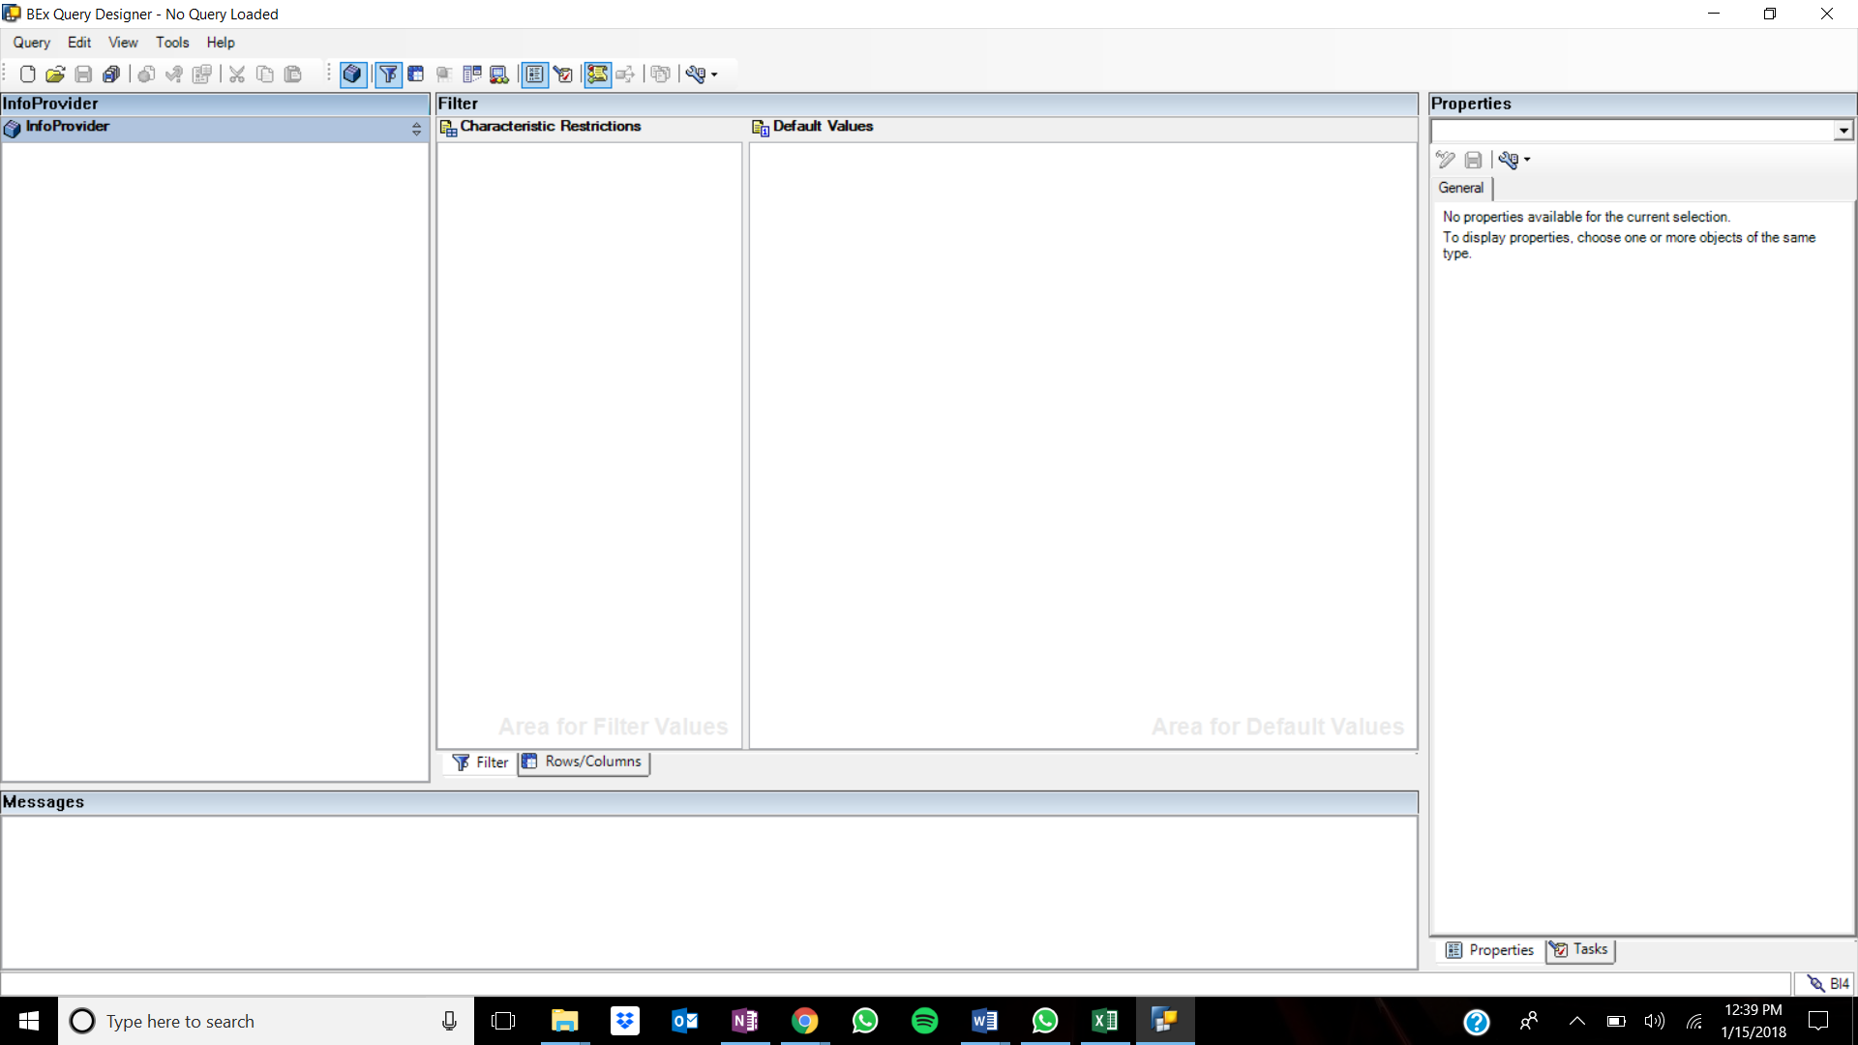

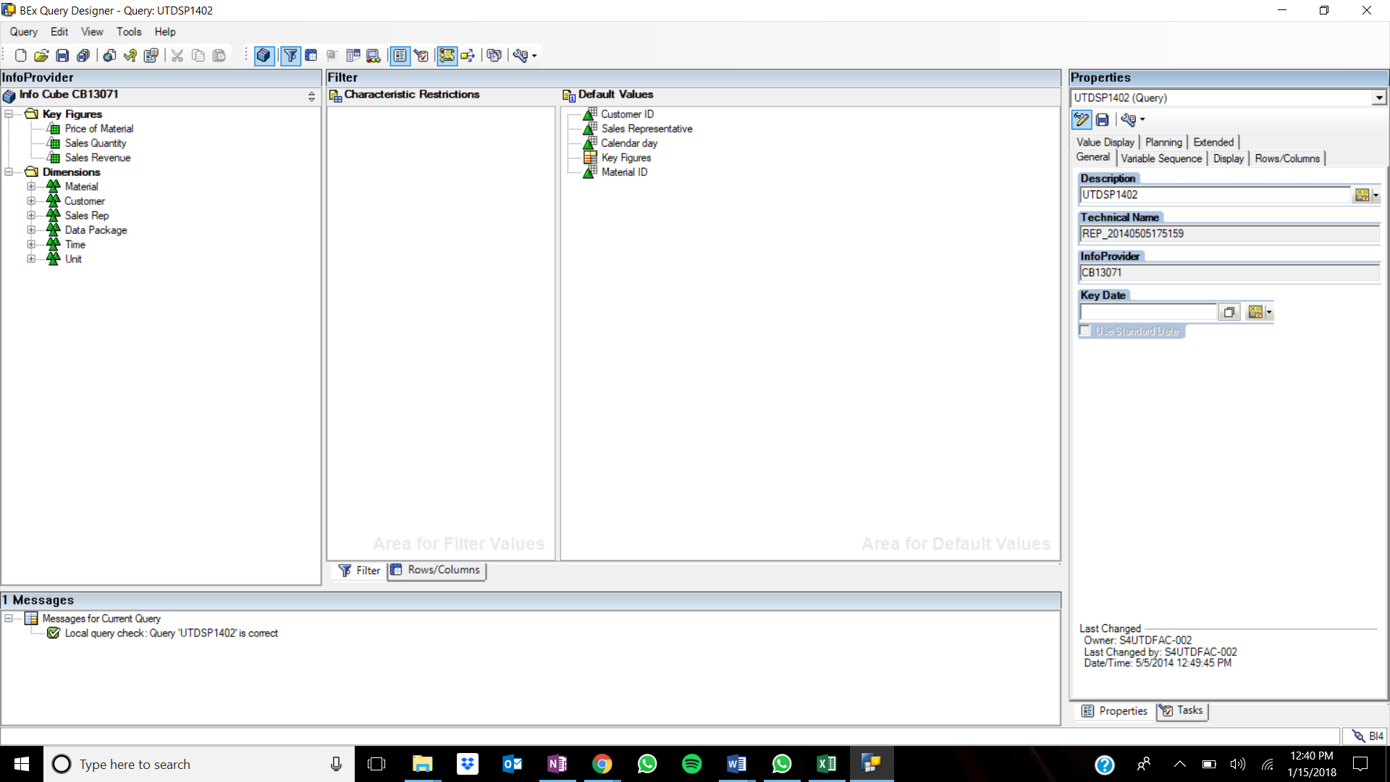

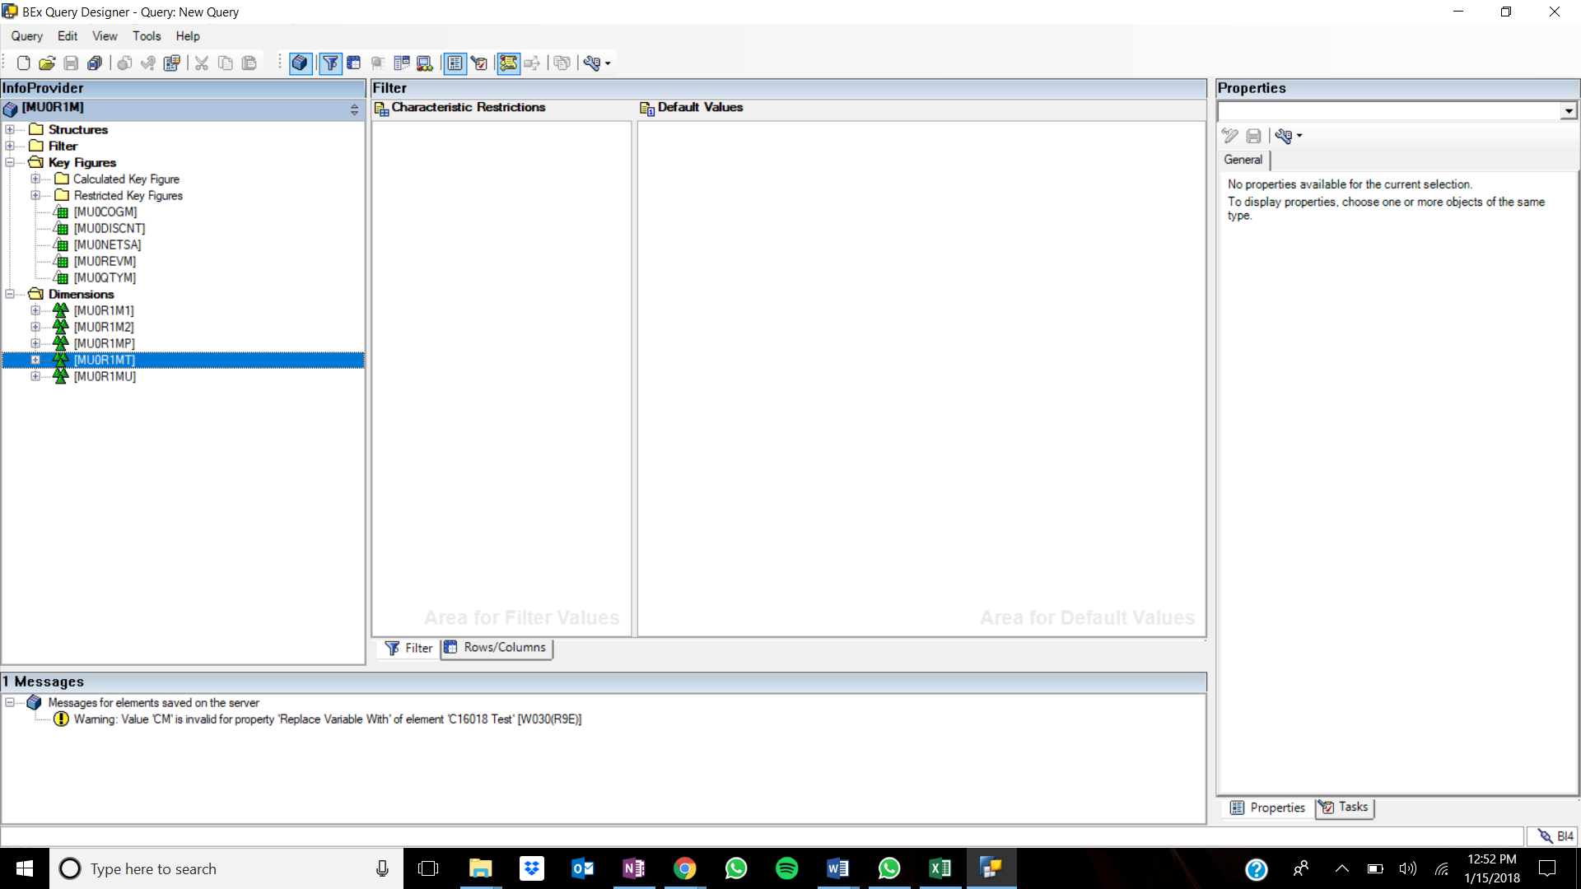

Pane 1: Info Provider – It is the left most pane that contains the characteristics, key figures, attributes and becomes the base to query upon to obtain the reports.

Pane 2: Characteristic Restriction – It is the pane under the filter which can be used to filter the data during query design and it cannot be changed outside the designer.

Pane 3: Default Values – This can be used to specify default values for the dimensions and key figures.

Pane 4: Free Characteristics – It is the pane under the rows/columns which can be used to filter the data during query design and it can be changed during the run time as well.

Pane 5: Columns – The characteristics or the key figures can be added to the column while designing the query.

Pane 6: Rows - The characteristics or the key figures can be added to the rows while designing the query.

Pane 7: Preview – This pane shows us how the resultant, without the data, of the query is going to be upon adding characteristics or key figures to the rows or columns.

Pane 8: Properties - This pane shows the properties of each of the components in the workbench.

Pane 9: Messages – This pane displays the error or success messages that happens when we build the query.

1. InfoProviders: The infoproviders are the objects that make the data available for analytical purposes.
2. InfoArea: Info Area is an area where all similar and related info objects are grouped together under one single area.
3. InfoObject: Info Object is the basic building block that is used to build all the other objects.
4. Dimension: A dimension is nothing but the characteristic
5. Characteristics: A Characteristic is a type of info objects that provides context for the business entities that are the subject of analysis.
6. Attribute: Attributes give additional information about the characteristics.
7. Key Figure: It is one of the objects that represents the numeric measures such as metrics of any business entities.

Step 7:

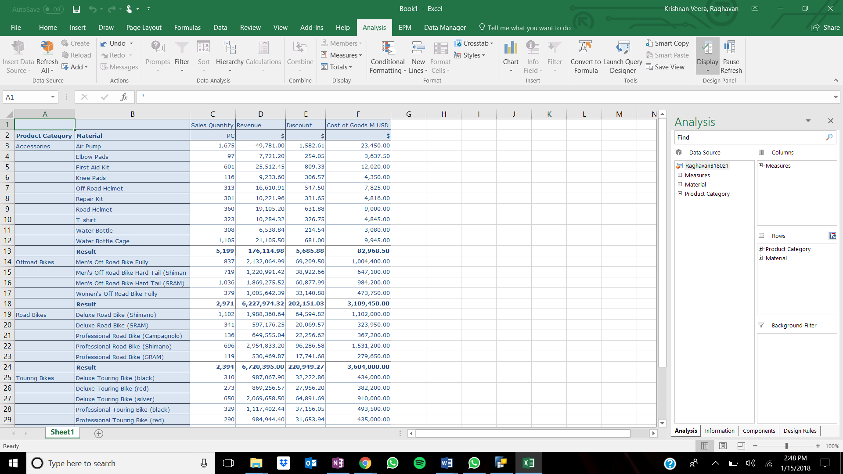

Step 8:

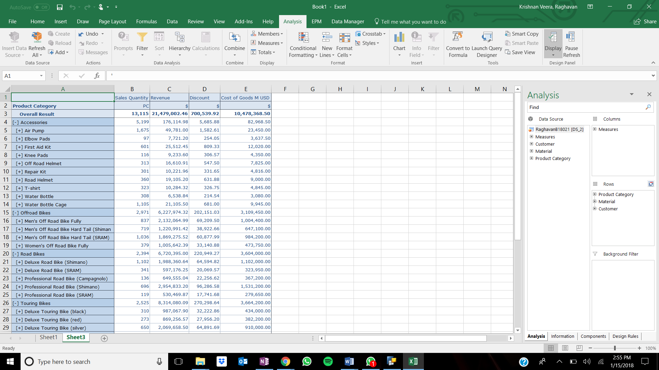

Step 9:

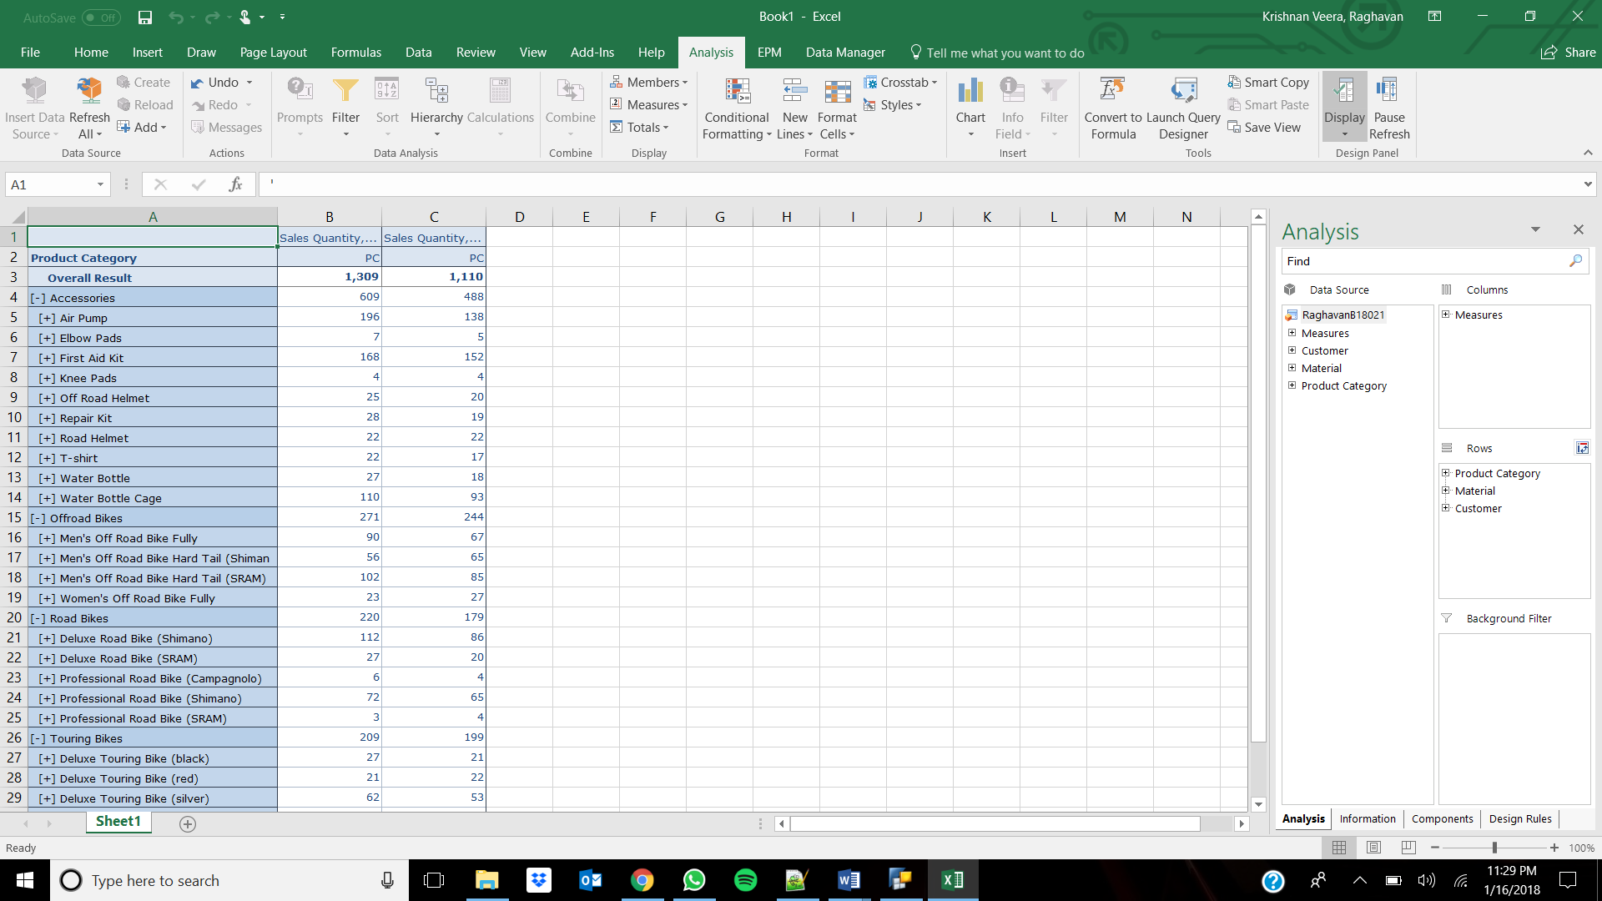

No, this type of comparison will not be possible with common drill down technique because we will not be able to display the aggregated sale quantity per quarter using the normal drill down technique.

Step 13:

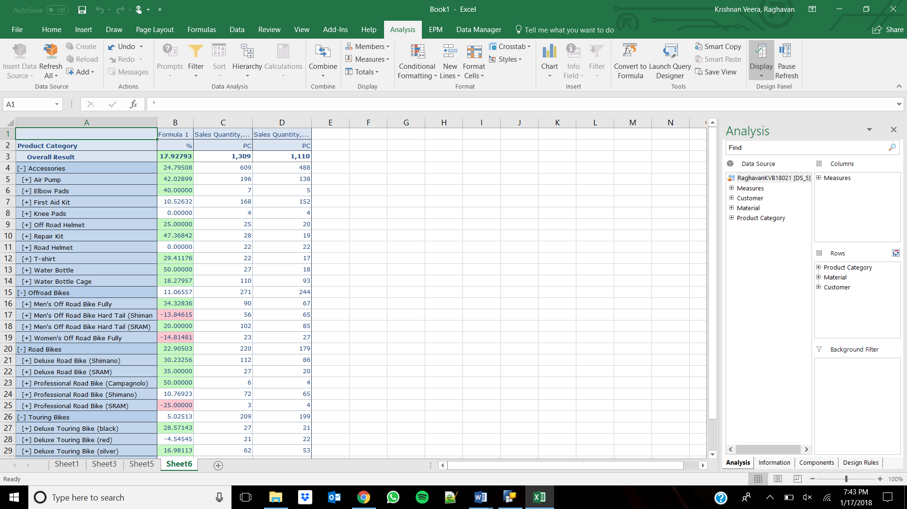

Step 15:

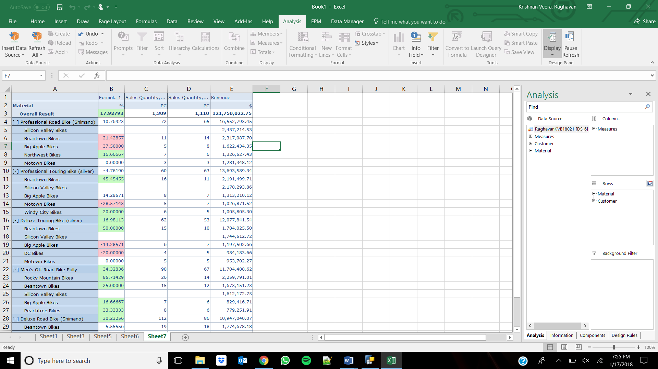

Step 16:

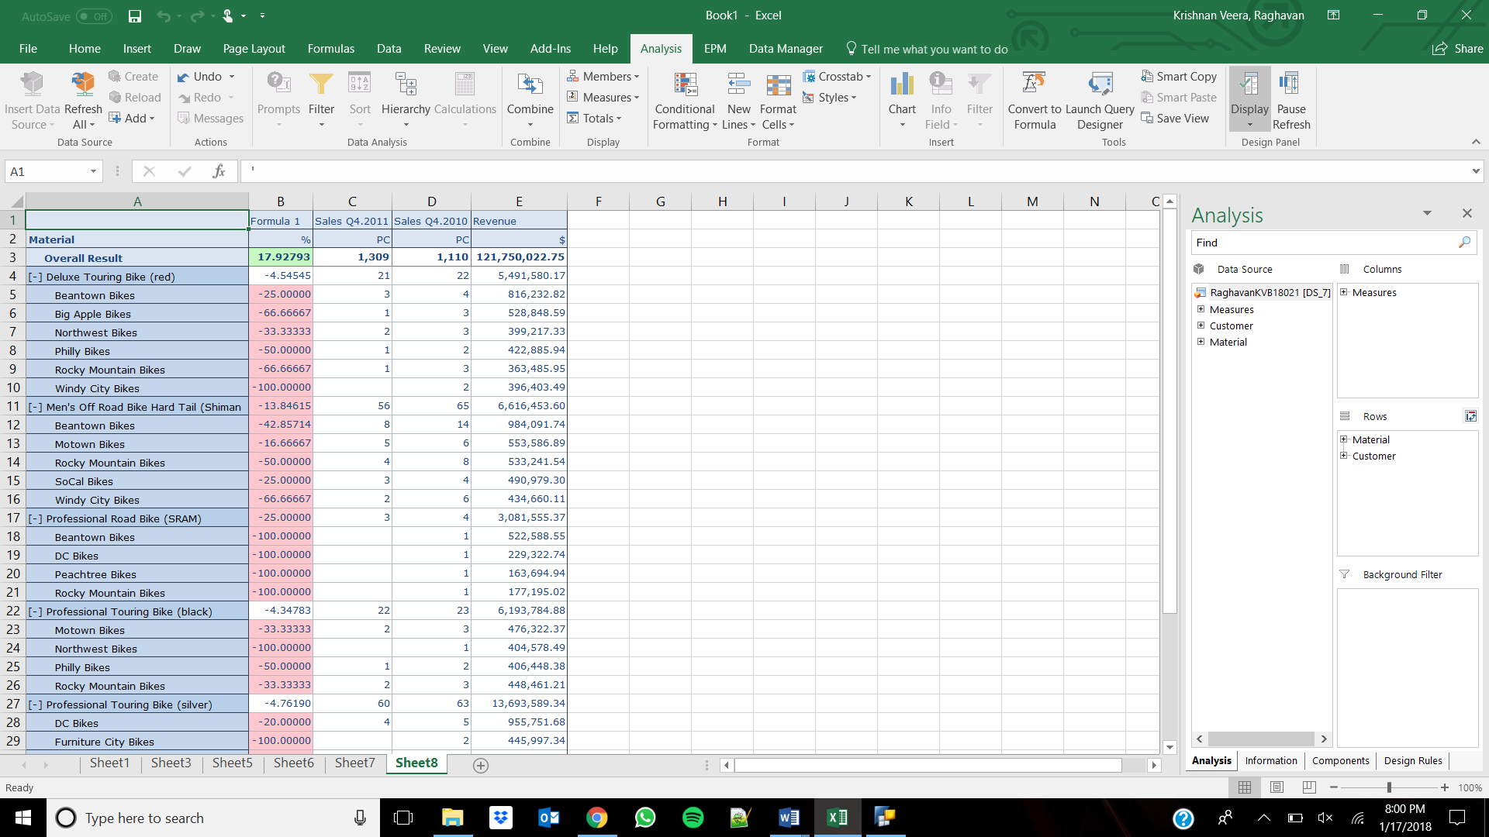

Step 18:

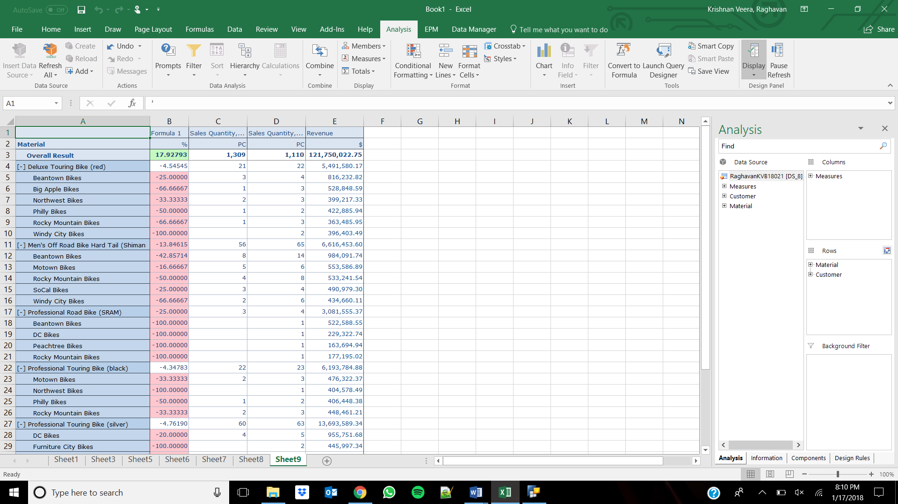

Step 19:

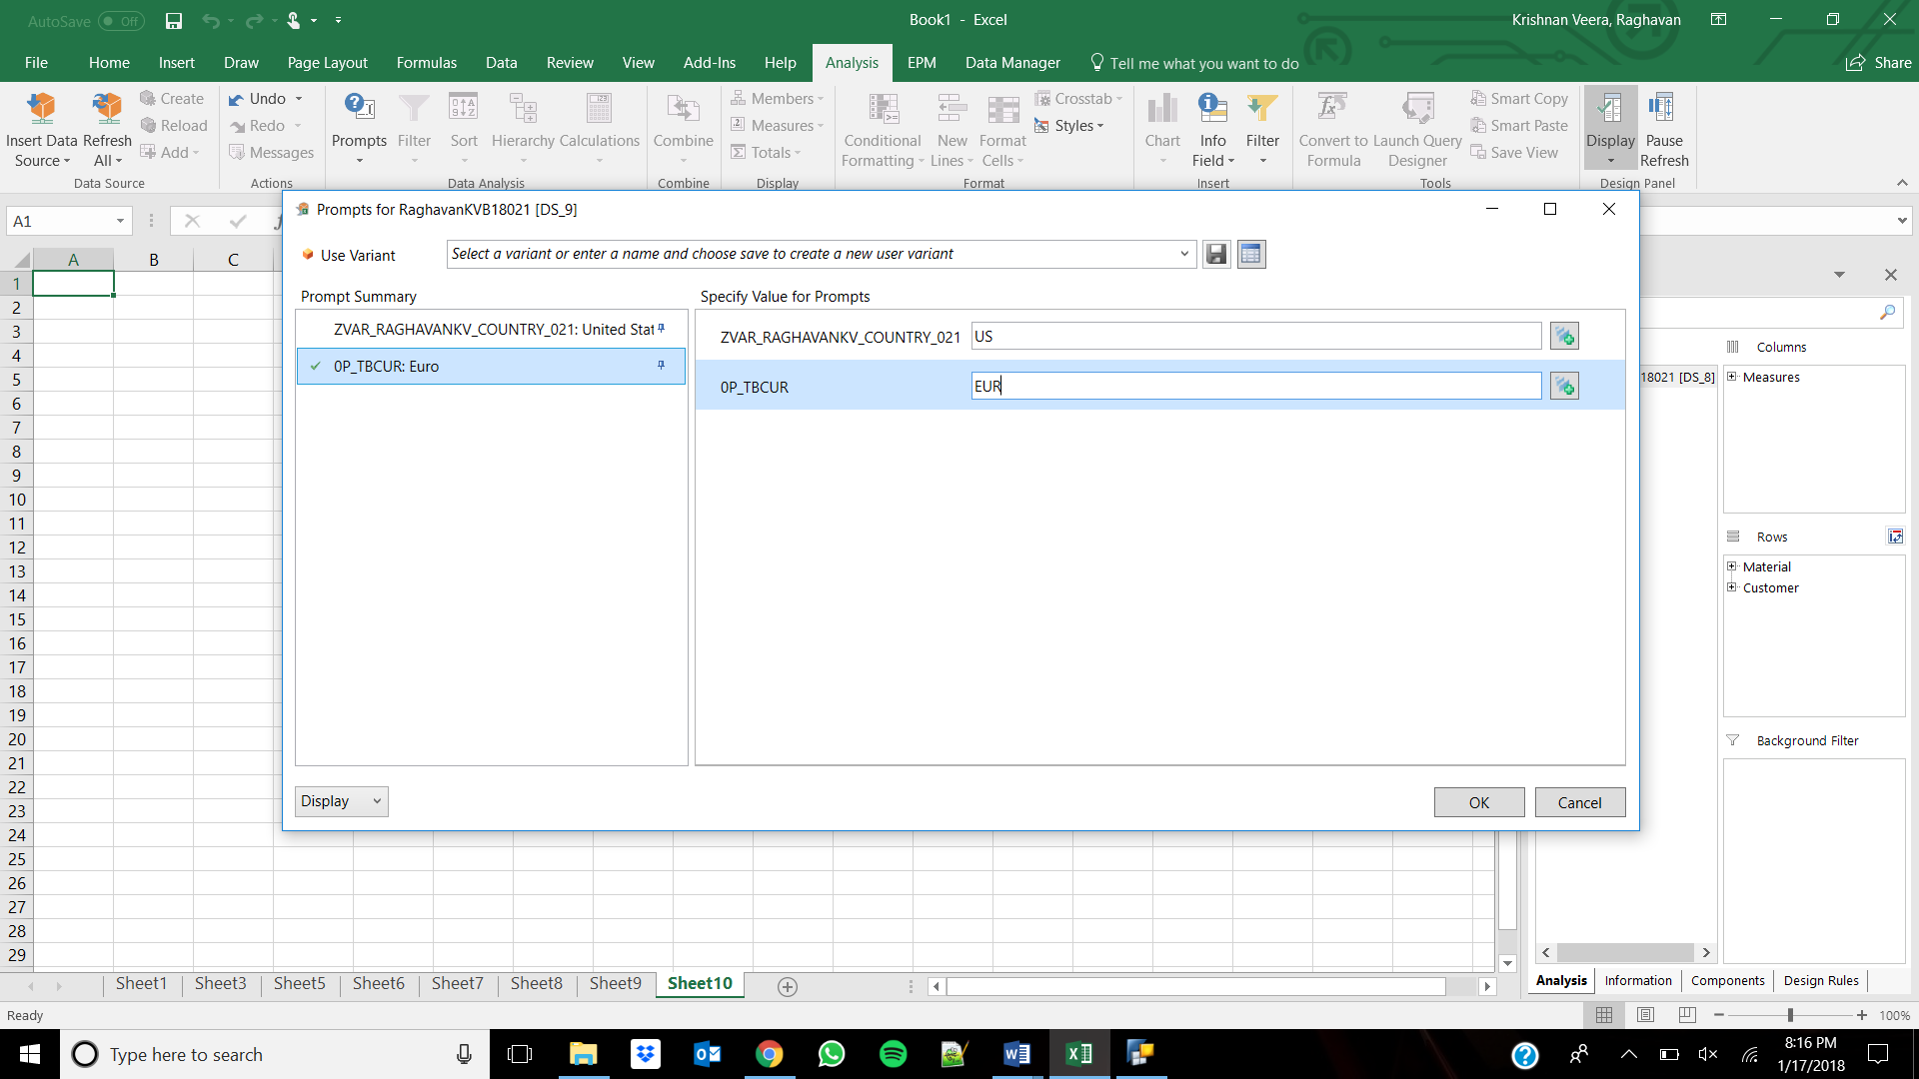

Description: Raghavan BW Query

Technical Name: BWUTDB180211